This n That

An e-mail newsletter from Agapé Athletics Club

Editor: Marieta Bortoli 082 466 7031 30 October 2017 www.agape.org.za

E-mail: marietabortoli@gmail.com

NB

- Next league race – Kolonnade Retail Park – 11 November
- Agapé AGM – 18 November

Editorial

Please remember to confirm your attendance to our AGM as we must make provision for catering.

All the best to our students who are currently writing exams. I trust that your studies will be successful.

Contents

# Birthday greetings
# Personalia
# Welcome new and former members
# Congratulations
# Thank you’s
# In the mailbox
# General
# Race reports / upcoming race information
# Race results
# Training/Health snippets
# Thought of the week
# Your smile for the week
# Something to ponder over / something spiritual
# AGN league logs
# Races cancelled
# Notice Board
# Photo corner

Notice Board Additions

● Muller Potgieter Road Race
●

Attachments

● AGM notice
Birthday Greetings
May the Lord bless you and send from above the peace of His presence, the joy of His love. May He grant you happiness in everything you do! Happy birthday!

Roald le Roux 31 October | Tebogo Lenogo 03 November
Johann van den Bergh 03 November | Pierre Bortoli 05 November
Simon Tseisa 16 November | James Kruger 17 November
Kevin Walsh 18 November | Christa Mouton 25 November
Jonathan Rossouw 25 November

Personalia

Welcome new and former members

Congratulations

Congratulations to the following members:

Thank you’s

In the mailbox

General
Clothing available:
Buffs @ R100
Ladies skirts @ R200
Second skins @ R170
Age tags @ R30

Please contact Marietjie if you wish to purchase some of the items:
Cell: 072 541 7268 E-mail: ventermarix9@gmail.com
The items will also be available at races, please visit our gazebo

Race reports/Upcoming race information

King Price Irene Farm Race 21km 28 October 2017 – Wallie Weder
Saturday morning was unusually cold and windy for this time of the year and especially in comparison with the heat we experienced earlier the week. The dark clouds caused drizzle and a real possibility of rain.

Having said that, still many runners pitched and huddled together at the start waiting for the gun to get moving and hopefully become warmer. Apparently, the walkers took longer to move out and as a result we started 3 minutes late aggravating the cold waiting time.

After the initial bit of a bundle and warm up, everything seemed to be going smoothly as we proceeded. The Kings cattle (not Price), they call them queens on this farm, do get preference according to the sign and do represent South Africa brilliantly in their colours and together with the Boeremusiek in the barn, gave a very specific farm ambiance to the race.

At about 5km Ken passed me so I still cannot call him “uncle” - and the reason why he only passed me then was that he must have been further behind at the start. We turned from the 5km and 10km runners into the residential area and to my utter enjoyment into a most scenic and beautiful rest of the race. At times branches and leaves would enfold us from above and in the taal of oom Jan: “omvou ons soos die Here se genade”. It seemed to change every time from road running to paving and even off road. We crossed a river over a concrete slab with beautiful willows. Then we moved alongside the golf course and even passed through a children’s playground just to add more variety to the experience and enjoyment of the day.

At the very end Harry and Wayne joined me as we finished the race together.

The race was well marked and water points sufficient and friendly manned. In all, a race I can highly recommend especially for its scenic route and rural ambiance Well-done Kings Price and Irene Running Club.

Race Results
CSIR - 10km race - 2017-10-21
Position | Initials | Surname | Sex | Age | Finish Time
266 | E | Dirkse Van Schalkwyk | F | 42 | 01:01:04
270 | K | Nurden | M | 82 | 01:01:17
274 | G | Brink | M |  | 01:01:26
283 | B | Beyers | F | 52 | 01:01:47
399 | G | Hughes | F |  | 01:06:16
488 | D | Benadie | F | 51 | 01:08:56
519 | J | Ferreira-prevost | F | 44 | 01:09:55
549 | Z | Hattingh | F | 37 | 01:10:43
550 | M | Hattingh | M | 37 | 01:10:52
573 | H | Venter | M | 58 | 01:11:41
614 | A | Potgieter | F | 46 | 01:12:50
634 | D | Frost | M | 61 | 01:13:35
884 | M | Stadler |  | 77 | 01:21:14
1065 | A | Te Reh | M | 68 | 01:28:02
1210 | S | Bothma | M | 43 | 01:36:38
1259 | G | Visser | M | 70 | 01:39:19
CSIR - 21km race - 2017-10-21
Position | Initials | Surname | Sex | Age | Finish Time
14 |  | Joseph | M | 46 | 01:25:03
65 | K | Imrie | M | 45 | 01:38:41
99 | J | Van Der Merwe | M | 48 | 01:43:36
300 | S | Marais-werner | F | 43 | 01:57:41
599 | H | Baker | M | 44 | 02:11:23
601 | M | Brummelkamp | M | 38 | 02:11:25
688 | M | Atkins | F | 48 | 02:14:25
689 | W | Unknown |  | 35 | 02:14:26
800 | A | Marais-werner | F | 43 | 02:18:53
862 | R | Le Roux | M | 62 | 02:21:32
965 |  | Groenewald | F | 48 | 02:25:55
981 | A | Lenoge | F | 44 | 02:26:28
982 | T | Lenoge | M | 47 | 02:26:31
1317 | E | Loubser | M | 60 | 02:54:26
1356 | M | Venter | F | 58 | 03:00:35
King Price Irene - 10km race - 2017-10-28
Position | Initials | Surname | Sex | Age | Finish Time
156 | K | Nurden | M | 80 | 00:58:31
401 | Z | Hattingh | F | 37 | 01:08:48
419 | A | Du Plessis | F | 62 | 01:09:40
693 | G | Visser | M | 70 | 01:25:45

Training/Health snippets

TRAINING WITH HEART RATE MONITORS
“I am the owner of a new heart rate monitor and a keen reader of instruction manuals. Therefore after a few weeks of use I feel it is important that I give my expert opinion on heart rate monitor’s uses, benefits and pitfalls. (I am a man; therefore, I know nearly everything: Only "nearly" because I am naturally modest). A technical piece of equipment like a heart rate monitor demands a certain learning curve. This means that you have to look at it whilst running, biking, etc, to see if you and it are doing the right thing. This has led to the following slight problems with the equipment: Twisting ankle in hole in road. Running into plastic rubbish bin outside gym…
Monitors also beep to tell you if you are "in the zone". I always seem to be "out" the zone. Best thing is to turn the beep off unless you wish to draw attention to your new heart rate monitor, and best way to get attention is to get on a treadmill next to someone with last year’s model or an obviously inferior piece of equipment. Look at yours often whilst it is beeping and then cast pitying looks at theirs.
It is amazing how many people ask you the time when you are running. Your monitor is monitoring everything about you except the time. This leads to strange looks when you tell people that you have no idea what the time is although you obviously have a large, expensive, beeping-watch on your arm. A slight variation on this is when you tell someone it is 7:90 when it is in fact 9.30 and you have just told them the altitude.
A survey has shown that 80% of gym people think that your heart rate strap is a kind of fashion bra for boys or a bondage fetish toy. If you run topless, (not advisable for girls) you will get strange looks of non-understanding, but if you wear a low-cut vest that only occasionally gives a glimpse of it, you will rapidly get the reputation of being strange and have all sorts of "interesting" people approach you with strange suggestions and innuendos.
A good heart rate monitor will take over the other equipment at the gym. Your heart rate will appear on the treadmills next to you. This can be great fun. Choose an out of shape person and get going at a slow pace. Their trainer will have told them to train at a certain heart rate level. Keep your heart rate very low and they will start trying harder and harder to reach their zone. This can result in them becoming exhausted and falling off the treadmill. Conversely you can cause a top athlete to train significantly beneath their level because they think your high heart rate is theirs. After a few minutes they will start slapping the treadmill display or holding their chest to see if their heart is really beating that fast.
You can use your expensive heart rate monitor in a variety of ways to come up with excuses for nonperformance. Knowing lots of big words helps with this technique. When the peleton rides away from you, you can knowingly say that your scientific program for the day is focusing on LSD training and you must keep your hr at low levels to ensure optimum aerobic conditioning. Of course, you mustn’t let them see it redlining at 190 or you will forever lose their respect. If someone of nearly equal strength looks like they are going to try to ride away from you on a hill, you can casually mention your incredibly low hr and psyche them out of the attempt. It helps if they also have a heart rate monitor and it is nearly redlining.
A heart rate monitor can also be used for interesting experiments at home. It is great fun to put it on a small child, see what their heart rate is and then give them a huge fright involving loud noises and an impersonation of Freddy Kruger. Their heart rate will immediately jump higher than a startled budgie. By the way, budgies actually do die of fright if you try this on them.

As you can see a heart rate monitor is a valuable item in an athlete’s arsenal and I suggest that you get one soon if you don't already partake of the pleasures... “

Your thought for the week

Education is the most powerful weapon you can choose to change the world!

Your smile for the week
As jy in Johannesburg of Pretoria bestuur, hier is die etiketsreëls wat jy moet volg:
*Flikkerligte verklap jou volgende beweging. 'n Ware Gautengbestuurder gebruik hulle nie.

*Jy moet onder geen omstandighede 'n veilige afstand tussen jou en die kar voor jou laat nie, want al wat dan gaan gebeur is dat iemand anders in die spasie gaan indruk en jou in nog 'n gevaarliker posisie plaas.

*Hoe vinniger jy deur 'n rooilig jaag, hoe kleiner is die kans dat iemand jou gaan raakry.

*Moet nooit ooit heeltemal tot stilstand by die stopstraat kom nie. Niemand verwag dit nie en dit sal veroorsaak dat iemand in jou vasry.

*Trap die rem so laat en hard as moontlik om seker te maak dat jou sluitweerremstelsel inskop en die polsende ritme van die rempedaal jou 'n heerlike voetmassering kan gee. Vir die armes wat nie sluitweerremme kan bekostig nie gee dit 'n goeie geleentheid om bene te rek.

*Moet nooit regs verbygaan as jy aan die linkerkant kan verby gaan nie. Dit is 'n goeie manier om mense wat by die deurpad wil aansluit te ontmoedig en verminder sodoende die verkeersdruk op die snelweg.

*Snelheidsperke is arbitrêre syfers en is slegs 'n voorstel en kan glad nie in spitstyd afgedwing word nie.

*Net omdat jy reeds in die regterbaan is en geen ruimte het om te versnel of verby te steek nie beteken dit nie jy kan nie op jou plek vinniger jaag nie.

*Ry baie stadiger en steek jou nek uit as jy 'n ongeluk langs die pad of selfs net iemand wat sy band ruil sien.

*Leer om baie vinnig uit te swaai. Die Gautengse departement van vervoer plaas slaggate op strategiese punte as deel van hulle 'Arrive Alive' program om te verseker dat bestuurders se reaksies skerp bly en hulle nie aan die slaap raak agter die stuur nie.

*Dit is gebruiklik in Gauteng om jou toeter te blaas as die motor voor jou nie binne twee millisekondes begin beweeg na die verkeerslig groen geslaan het nie.

*Onthou dat die hoofdoel van elke Gautengse bestuurder is om eerste daar te wees, maak nie saak hoe nie.

Something to ponder over / something spiritual

When you hold both hands together in front of you, and you are not sure what to pray, remember…
1. Your thumb is nearest you. So, begin your prayers by praying for those closest to you. They are the
easiest to remember. To pray for our loved ones is, as C. S. Lewis once said, a "sweet duty."
2. The next finger is the pointing finger. Pray for those who teach, instruct and heal. This includes teachers,
doctors, and ministers. They need support and wisdom in pointing others in the right direction.
Keep them in your prayers.
3. The next finger is the tallest finger. It reminds us of our leaders. Pray for the president, leaders in
business and industry, and administrators. These people shape our nation and guide public opinion.
They need God's guidance.
4. The fourth finger is our ring finger. Surprising to many is the fact that this is our weakest finger; as any
piano teacher will testify. It should remind us to pray for those who are weak, in trouble or in pain.
They need your prayers day and night. You cannot pray too much for them.
5. And lastly comes our little finger; the smallest finger of all which is where we should place ourselves in
relation to God and others. As the Bible says, "The least shall be the greatest among you." Your pinkie
should remind you to pray for yourself. By the time you have prayed for the other four groups, your own
needs will be put into proper perspective and you will be able to pray for yourself more effectively.
This is beautiful - and it is surely worth making the 5 Finger Prayer a part of our lives
League results
Cancelled Races

Notice Board

Useful Links:
www.raceresults.co.za/flyers - for the latest race pamphlets
www.agn.co.za/#League for the latest league logs and the league points you earned
http://www.agn.co.za/Docs/2016/WAlking/AGN%20road%20walking%20stds%20ref%20685.pdf
AGN 2016 RW qualifying standards and selection criteria
www.runawaysport.co.za Run-A-Way Sport’s web site
www.verticalhorison.co.za Trail Running www.trailseries.co.za Trail Running
http://www.mastersathletics.net/Age-Graded-Calculator.2595.0.html Age Graded Calculator
http://www.sportsinjuryclinic.net/symptom-checker By clicking where it hurts then ticking which symptoms most apply to you we can give you an indication of what injuries may apply.

Saturday 4 November BDS Unlimited Road Race 21.1/10/5 km
Race Organisers: Black Diamonds Athletics Club
Venue: Wonderpark Shopping Centre, c/o Brits Rd & Heinrich Ave, Karenpark
GPS: S 25 40,264 E 28 6,703

 | 21.1 km | 10 km | 5 km
Pre- Entry fee | R 80 | R 60 | R 50
Late Entry fee | R 90 | R 70
Entry fee 60+ | R 50 | R 40
Entry fee 70+ & blind runners | Free
Start Time | 06:00 |  | 06:15
Cut-off | 04:30

No pets allowed
Race is wheelchair friendly

Pre-entries at: Run-away Sport; Sweatshop Southdowns; Virgin Active Wonderpark; Dirtylolli Wonderpark

www.entrytime.com

Saturday 4 November Oppie Bol Disability Festival Run 21.1/10/5/2.5 km
Race Organisers: Oppie Bol Athletics Club
Venue: Toutrek Park, c/o Nico Smith & 14th Avenue, Retfontein

 | 21.1 km | 10 km | 5 km | 2.5 km
Entry fee | R 70 | R 60 | R 30 | R 20
Start Time | 06:00 | 06:15 | 06:30
Cut-off | 03:30

There is also a 21.1km cycle race @ 05h50o pets allowed
Race is wheelchair friendly

http://qkt.io/Oppiebol

League Race
Saturday 11 November Kolonnade Retail Park Road Race 21.1/10/6 km
Race Organisers: Run/Walk for Life Athletics Club
Venue: Kolonnade Retail Park, Sefako Magatho (Zambesi) Drive, Montana Park
GPS: S 25 40’39” E 28 15’13”

 | 21.1 km | 10 km | 6 km
Entry fee | R 80 | R 60 | R 40
Start Time | 06:00
Cut-off | 03:00

No pets allowed
Race is wheelchair friendly

Pre-entries at: Run-away Sport; Sweatshop Southdowns; Running Shop Vinko St Sinoville; Sportmans Warehouse Kolonnade Retail Park

www.enteronline.co.za

Saturday 18 November Tom Jenkins Run/Walk Challenge 21.1/10/5 km
Race Organisers: Arcadia Running Club
Venue: Pretoria Union Buildings, Church Street, Arcadia
GPS: S 27.7402 E 28.2102

 | 21.1 km | 10 km | 5 km
Entry fee | R 100 | R 80 | R 50
Start Time | 06:00 |  | 06:20
Cut-off | 03:00

Pre-entries at: Run-away Sport; Sweatshop Southdowns; Tshwane Running Shop

www.enteronline.co.za

Saturday 25 November Muller Potgieter Road Race 21.1/10/5 km
Race Organisers: Voortrekker Monument Klub
Venue: Military Sports Club, Hendrik Potgieter Road, Thaba Tshwane (Valhalla)
GPS: S 25.471160 E 28.081530

 | 21.1 km | 10 km | 5 km
Entry fee | R 90 | R 70 | R 40
Jardine Joggers & 60+ | R 40
Start Time | 06:00 |  | 06:15
Cut-off | 03:00

Pre-entries at: Run-away Sport; Postnet Pretoria West; Sportmans Warehouse Atterbury Value Mart, Centurion, Menlyn Park & Kolonade

www.entrytime.com

2017 AGN LEAGUE FIXTURE LIST
EVENT | DISTANCE | DATE | LEAGUE
 |  |  | RR | RW
Kolonnade Retail Park | 10 / 21.1 km | 11/11/17 | X | X

Masters Athletics Fixture list

Local meetings
11 November 2017 Free State Bloemfontein

Time Trials:

Centurion -
Lewende Woord Centurion on Wednesdays at 17:30
Contact Marinda 654 5800 (h) 082 720 9017

Rietondale –
North Street, Rietondale (Rietondale Park in the street before the Crawford Stadium) Thursdays 17:30
Contact Dorothy Benadie 082 704 2300 dorothy.benadie@gmail.com or
Hennie Venter 083 702 4472

Zita Park - Tuesdays at 17:30
Zita Street, Zita Park, Garsfontein
Contact Hennie Venter – 083 702 4472 Marietjie Venter – 072 541 7268

Gazebo Enquiries

Hennie Venter – 083 702 4472 Marietjie Venter – 072 541 7268

Intercessor:



Fred Harding 076 777 7786

Agapé Executive 2016/2017

Name | Position | Telephone number | E-mail address
Marieta Bortoli | Chairperson & editor | 012 331 2089  082 466 7031 | marietabortoli@gmail.com
Hennie Venter | Registrar & club captain | 083 702 4472 | henniev@seng.co.za  join@agape.org.za
Marilett Jenkins | Secretary | 082 837 2142 | marilett.jenkins@mervitzmalan.co.za
André Breytenbach | Treasurer | 083 566 1090 | andreb@geoscience.org.za
De Wet de Beer | PRO & vice-chairman | 082 373 2987 | dewet@styletechnique.co.za
Kobus Stander | Race organiser | 082 688 6697 | CLK1560PHARM@clicks.co.za
Fred Harding | Intercessor | 076 777 7786 | fredharding@telkomsa.net
Marietjie Venter | General activities & clothing co-ordinator | 072 541 7268 | Ventermarix9@gmail.com
Gustav Brink | Statistician | 083 417 8431 | gustav.brink@gmail.com

Photo corner

Agapé Executive

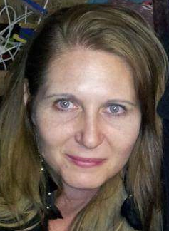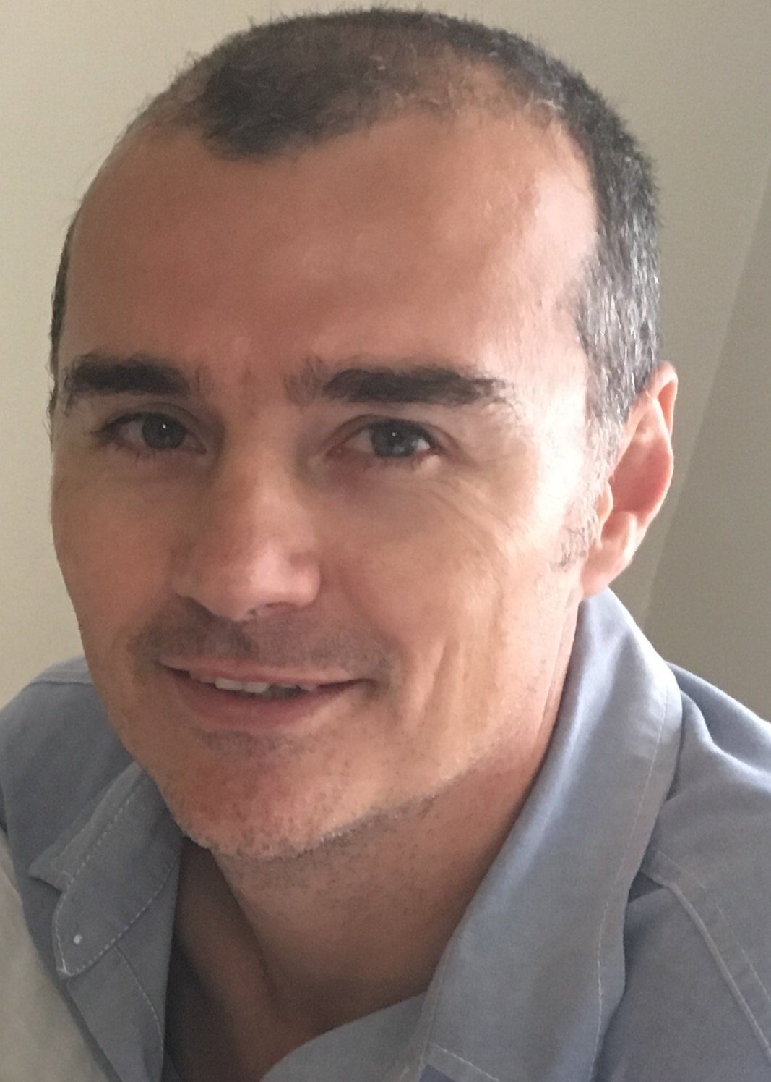
Marieta Bortoli Marilett Jenkins De Wet de Beer

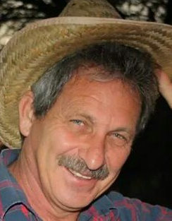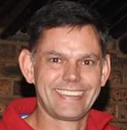
Hennie Venter André Breytenbach Kobus Stander

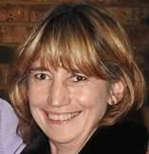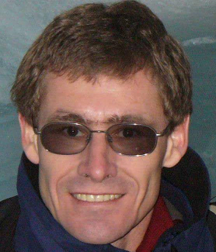
Marix Venter Fred Harding Gustav Brink (Ex-officio)

